iPhone X Biology Page

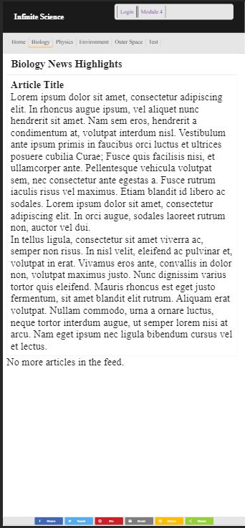

iPad Physics Page:

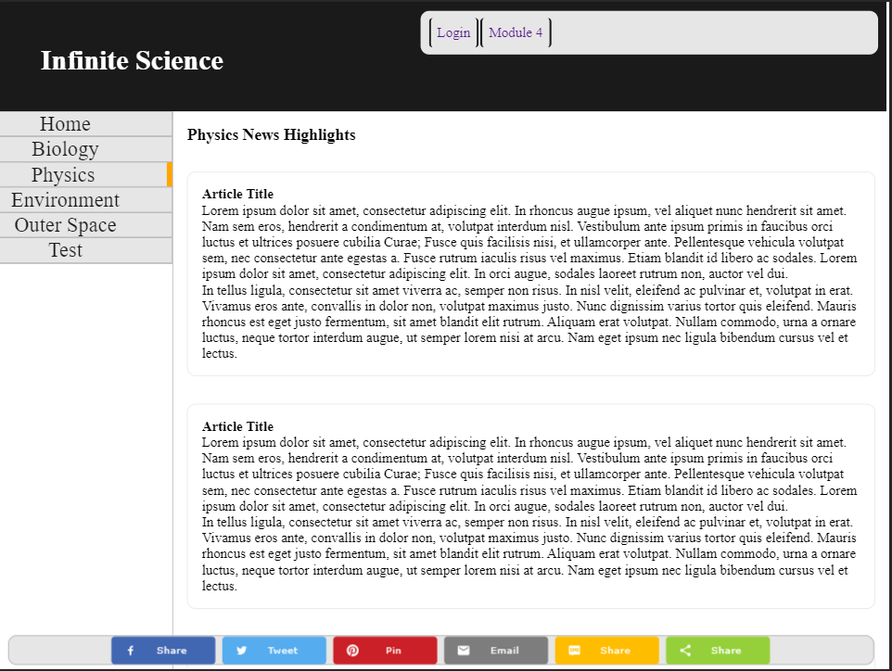

The iPad / tablet example displays the same as a desktop. At 100% zoom it all checks out. If I were to pair any articles to this physics page, I’d be delving into all the discoveries around quantum mechanics, nuclear fusion, quantum radar, etcetera. I could create containers inside the article box div that I have set up, one holding a picture for the story, and the rest a small description of the article, then linking into the actual webpage for that specific article. The idea is to create an RSS feed of news articles. Having a utility navbar at the top with a topics navbar to the side or directly above the content (depending on device) seems like a solid start to a layout for something like this.  
  
In this page, the width of the navbar is 200px, the main body is set 200px in, width 100% - 200px, there is some great realestate to present ads or some other third party linkage under the navbar, and it could be done again on the right if needed.

iPhone 5 Outer Space Page:

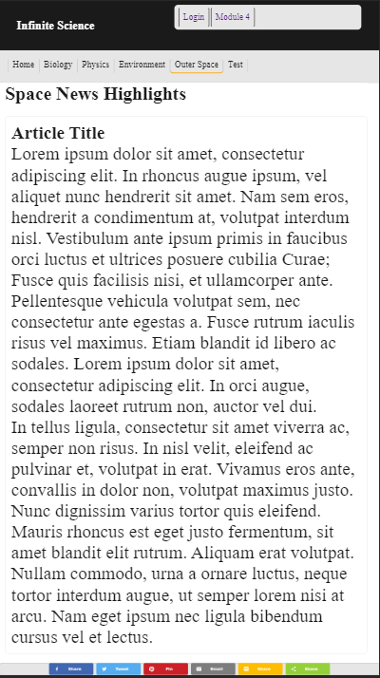

Small phones fit a single article body perfectly. I’m very happy with this view. The one thing I may expand is the font size of the nav bars.

The utility bar has some room to take up, the topics bar could grow a little bit too.

Pixel 2 Outer Space Page:

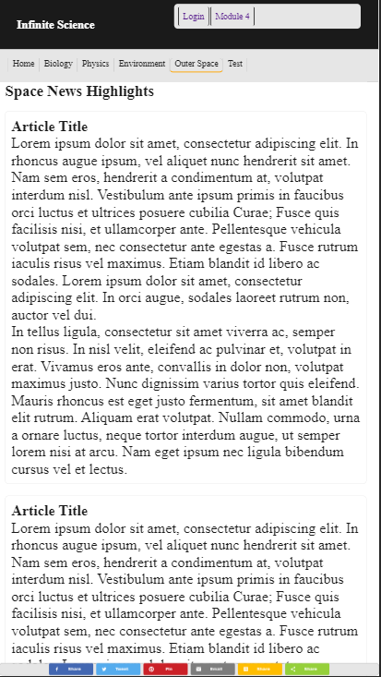

Here’s a view that catches one full article box, and the beginning of a second one. There could be a div created to hold third party linkage that appears between article boxes maybe, in an effort to monetize something like this. The nav bars are both more legible in this view, font size is scaling to the size of the screen better here.

iPad Pro Environment Page

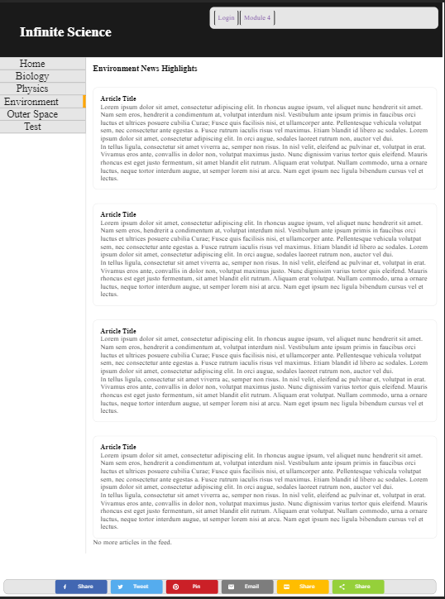

This display really highlights the core structure of the website as a news feed. The main columns of text seem to be a little wide perhaps. For the purpose of a website like this, large paragraphs wouldn’t typically be displayed, instead linking into individual articles, with a thumbnail picture and headline taking up most of the space on the feed instead. I’m interested in delivering shorter stories with content paired with the headlines though, so it could work out in a system where users don’t have to leave the original feed to read the gist of a story. But again, the structure of the articles is really the big project and requires more work on the back end before I can really do much with the front end. These article structures are completely static right now.